Tucson Celtic Festival Association

2017 Board of Directors
Dale Pederson, President
Steve Mackie, V. President
Sarah Mackie, Treasurer
Erin Haugen, Secretary
Charles Gilbert.Member at Large
Don Appleton, Member at Large
Greg Landers, Member at Large

Tucson Celtic Festival
&
Scottish Highland Games
November 3-November 5, 2017

Rillito Park Raceway
4502 N. First Ave.

Tucson, AZ 85718
520-440-8578
www.TucsonCelticFestival.org

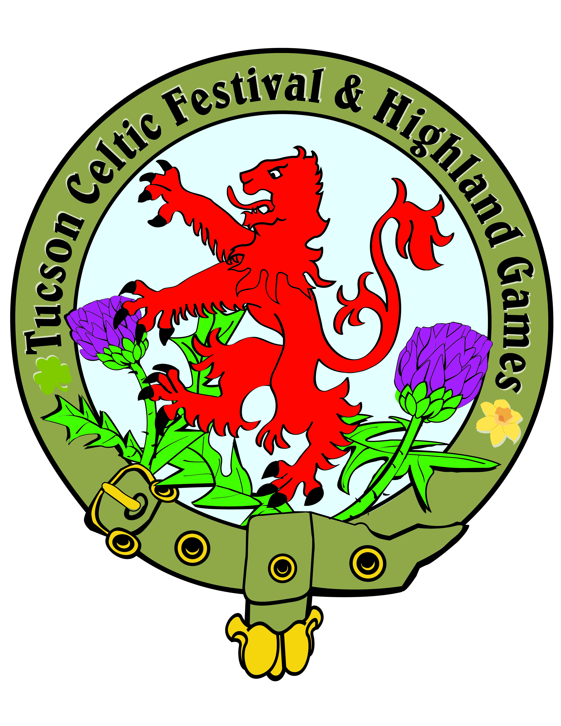

Dear Clansmen and Fellow Celts,

We are excited and pleased to invite you to this year’s 31st Annual Tucson Celtic Festival and Scottish Highland Games! The festival will begin Friday evening, November 3 at 5:00, with an adult Pub Night Ceilidh with the bars open with food and festivities until 9:30 pm. The Festival continues on Saturday, November 4 from 9:00am – 10:00pm and Sunday, November 5 from 9:00am to 4:00pm. The location remains the same - at the Rillito Raceway Park, 4502 N. First Ave., Tucson, Arizona 85718.

Participating Clans and Societies reserving a space may set up on Friday, November 3 from Noon to about 5:00pm. Golf carts will be available on Friday to assist in getting your equipment onto the field. If you don’t think you can be finished by 5:00 pm, let us know. A bit later is possible and/or you can finish setting up early Saturday morning, from 7:30-8:30 am.

The new Clan area is close to the racetrack and very accessible but in order to limit the driving on the grass, we will plan to meet you with golf carts to help you with transport for you and your equipment.

Friday night the pub will be open, good food will be available and there will be festive entertainment. Our field is lighted in the evening so plan to stay and enjoy. Bring a wrap because it chills down considerably after sunset. We ask that your Clan or Society representative be in full attire for the Ceremony and ready to announce your presence to the Chief of the Games at the traditional Torchlight Ceremony at 8:00.

The Opening Ceremony for the Festival will be Saturday at 12:30. If you are participating in the Parade of Clans, instructions will be provided with your final packet of information. Be sure to hold your banners high! If you have dignitaries attending, please make us aware so they may be announced and recognized. The Closing Ceremony will be on Sunday at about 4:00pm. Please don’t plan to pack up until 5:00 on Sunday – we will have volunteers and carts to help you exit the field after 5. We really look forward to seeing you again this year as we celebrate another Celtic Festival in Tucson! Your tickets and other information will be available when you check-in on Friday.

If you would like to set up and attend the festival ONLY on Saturday then we will have some spaces in the second tier available for set up on Friday or early Saturday (7:00 to 8:30 am) and then we will be available to help you exit your space after 5:00 Saturday night. We are hoping this will allow some clans that are unable to commit to all three days to attend and participate on Saturday. If you have clan friends who might benefit from this new option, please spread the word!

Slainte,

Dale Pederson, President, TCFA
Steve Mackie, Clans & Societies Chairman

p.s. Since we received so many compliments last year, we are producing a full-color commemorative program again this year! Here is an opportunity for your clan to promote your unique history, traditions and upcoming events. Spaces from business – card to full page are available for purchase. For complete information contact Greg at tcfa.vendors@gmail.com.

